Project Code | Source
Data Manipulation | Source: Mini Project 1 Data Manipulation code  Original Code:  Initial wrangling code  " population <- read_csv("data/raw/pop.csv") |> select(geo, name, population = 2025)  life_expectancy <- read_csv("data/raw/lex.csv") |> select(geo, name, life_expectancy = 2025)  sanitation_access <- read_csv("data/raw/at_least_basic_sanitation_overall_access_percent.csv") |> select(geo, name, sanitation_access_pct = 2024)  murder_deaths <- read_csv("data/raw/murder_total_deaths.csv") |> select(geo, name, murder_total_deaths = 2023)  food_supply <- read_csv("data/raw/food_supply_kilocalories_per_person_and_day.csv") |> select(geo, name, food_supply_kcal_per_person_day = 2022)  child_deaths <- read_csv("data/raw/number_of_child_deaths.csv") |> select(geo, name, number_of_child_deaths = 2022)  female_head_of_state <- read_csv("data/raw/female_hos.csv") |> select(geo, name, female_head_of_state = 2021)  project1_2025 <- life_expectancy |> left_join(population, by = c("geo", "name")) |> left_join(sanitation_access, by = c("geo", "name")) |> left_join(murder_deaths, by = c("geo", "name")) |> left_join(food_supply, by = c("geo", "name")) |> left_join(child_deaths, by = c("geo", "name")) |> left_join(female_head_of_state, by = c("geo", "name"))  project1_2025 <- project1_2025 |> mutate(murder_deaths_per_100k = (murder_total_deaths / population) * 100000, child_deaths_per_100k = (number_of_child_deaths / population) * 100000)  project1_2025 <- project1_2025 |> mutate(female_hos_binary = if_else(female_head_of_state == "Had a female head of state", 1, 0, missing = NA_real_))  project1_2025 <- project1_2025 |> select(-murder_total_deaths, -number_of_child_deaths, -population, -female_head_of_state)  write_csv(project1_2025, "data/project1_2025_merged.csv")
Exploratory Data analysis – Continuous Variables  #| include: false  long_data <- project2_merged |>  pivot_longer(  cols = c(sanitation_access_pct, food_supply_kcal_per_person_day,  murder_deaths_per_100k, child_deaths_per_100k),  names_to = "variable",  values_to = "value"  )  make_plot <- function(var, ylab) {  graph <- long_data |>  filter(variable == var) |>  ggplot(aes(x = Democracy, y = value, fill = Democracy)) +  geom_boxplot(width = 0.6, outlier.shape = 21, outlier.size = 2) +  labs(title = paste(ylab, " by Democracy Status"), x = "Democracy Status", y = ylab, fill = "Group") +  theme_minimal(base_size = 13) +  theme(  axis.text.x = element_text(angle = 45, hjust = 1),  legend.position = "bottom"  )  graph  }  make_table <- function(var) {  table <- project2_merged |>  summarise(  n = sum(!is.na(.data[[var]])),  mean = mean(.data[[var]], na.rm = TRUE),  median = median(.data[[var]], na.rm = TRUE),  sd = sd(.data[[var]], na.rm = TRUE),  min = min(.data[[var]], na.rm = TRUE),  max = max(.data[[var]], na.rm = TRUE),  )  print(table)  }  make_outlier <- function(var) {  table <- project2_merged |>  mutate(  q1 = quantile(.data[[var]], .25, na.rm = TRUE),  q3 = quantile(.data[[var]], .75, na.rm = TRUE),  iqr = q3 - q1,  is_out = .data[[var]] < q1 - 1.5*iqr |  .data[[var]] > q3 + 1.5*iqr  ) |>  filter(is_out) |>  slice_max(abs(.data[[var]] -  median(.data[[var]], na.rm = TRUE)), n = 5) |>  select(name, Democracy, .data[[var]])  print(table)  }  p1 <- make_plot("sanitation_access_pct", "Sanitation access (%)")  p2 <- make_plot("food_supply_kcal_per_person_day", "Food supply (kcal/person/day)")  p3 <- make_plot("murder_deaths_per_100k", "Murder deaths per 100k")  p4 <- make_plot("child_deaths_per_100k", "Child deaths per 100k")  t1 <- make_table("sanitation_access_pct")  t2 <- make_table("food_supply_kcal_per_person_day")  t3 <- make_table("murder_deaths_per_100k")  t4 <- make_table("child_deaths_per_100k")  o1 <- make_outlier("sanitation_access_pct")  o2 <- make_outlier("food_supply_kcal_per_person_day")  o3 <- make_outlier("murder_deaths_per_100k")  o4 <- make_outlier("child_deaths_per_100k") | Source: Adapted three code blocks from two different prompts from DeepSeek AI.  Prompt: Give me a function that displays box plots for sanitation_access_pct, food_supply_kcal_per_person_day, murder_deaths_per_100k, child_deaths_per_100k versus democracy from project2_merged  Response:  library(tidyverse)  long_data <- project2_merged |> pivot_longer( cols = c(sanitation_access_pct, food_supply_kcal_per_person_day, murder_deaths_per_100k, child_deaths_per_100k), names_to = "variable", values_to = "value" )  make_plot <- function(var, ylab) { long_data |> filter(variable == var) |> ggplot(aes(x = Democracy, y = value, fill = Democracy)) + geom_boxplot(width = 0.6, outlier.shape = 21, outlier.size = 2) + labs(title = var, x = NULL, y = ylab, fill = "Group") + theme_minimal(base_size = 13) + theme( axis.text.x = element_text(angle = 45, hjust = 1), legend.position = "bottom" ) }  p1 <- make_plot("sanitation_access_pct", "Sanitation access (%)") p2 <- make_plot("food_supply_kcal_per_person_day", "Food supply (kcal/person/day)") p3 <- make_plot("murder_deaths_per_100k", "Murder deaths per 100k") p4 <- make_plot("child_deaths_per_100k", "Child deaths per 100k")  p1; p2; p3; p4  Prompt: give me code that displays summary statistics for the same variables and outliers  Response: library(tidyverse)  # ---------- Summary stats ----------  project2_merged |>  summarise(  n = sum(!is.na(murder_deaths_per_100k)),  mean = mean(murder_deaths_per_100k, na.rm = TRUE),  median = median(murder_deaths_per_100k, na.rm = TRUE),  sd = sd(murder_deaths_per_100k, na.rm = TRUE),  min = min(murder_deaths_per_100k, na.rm = TRUE),  max = max(murder_deaths_per_100k, na.rm = TRUE)  )  # ---------- 5 outliers by name ----------  project2_merged |>  mutate(  q1 = quantile(murder_deaths_per_100k, .25, na.rm = TRUE),  q3 = quantile(murder_deaths_per_100k, .75, na.rm = TRUE),  iqr = q3 - q1,  is_out = murder_deaths_per_100k < q1 - 1.5*iqr |  murder_deaths_per_100k > q3 + 1.5*iqr  ) |>  filter(is_out) |>  slice_max(abs(murder_deaths_per_100k -  median(murder_deaths_per_100k, na.rm = TRUE)), n = 5) |>  select(name, Democracy, murder_deaths_per_100k)
Exploratory Data Analysis – Categorical  ggplot(project2_merged, aes(x = female_hos_binary, fill = Democracy)) + geom_bar(position = "fill") + labs( title = "Democracy Status by Female Head of State", x = "Female head of state (binary)", y = "Proportion", fill = "Democracy" ) + theme_minimal(base_size = 13)  #two way table  as.data.frame(table(project2_merged$female_hos_binary, project2_merged$Democracy))  #row proportions  as.data.frame(prop.table(table(project2_merged$female_hos_binary, project2_merged$Democracy), margin = 2))  #column proportions  as.data.frame(prop.table(table(project2_merged$female_hos_binary, project2_merged$Democracy))) | Source: Deepseek  Promt: make a stacked bar chart of y value Democracy vs x value female_hos_binary using project2_merged  Response:  library(ggplot2) library(dplyr)  ggplot(project2_merged, aes(x = female_hos_binary, fill = Democracy)) + geom_bar(position = "fill") + labs( title = "Democracy Status by Female Head of State", x = "Female head of state (binary)", y = "Proportion", fill = "Democracy" ) + theme_minimal(base_size = 13)  Source: Google  Link: https://www.rdocumentation.org/packages/base/versions/3.6.2/topics/prop.table
KNN Classification Model  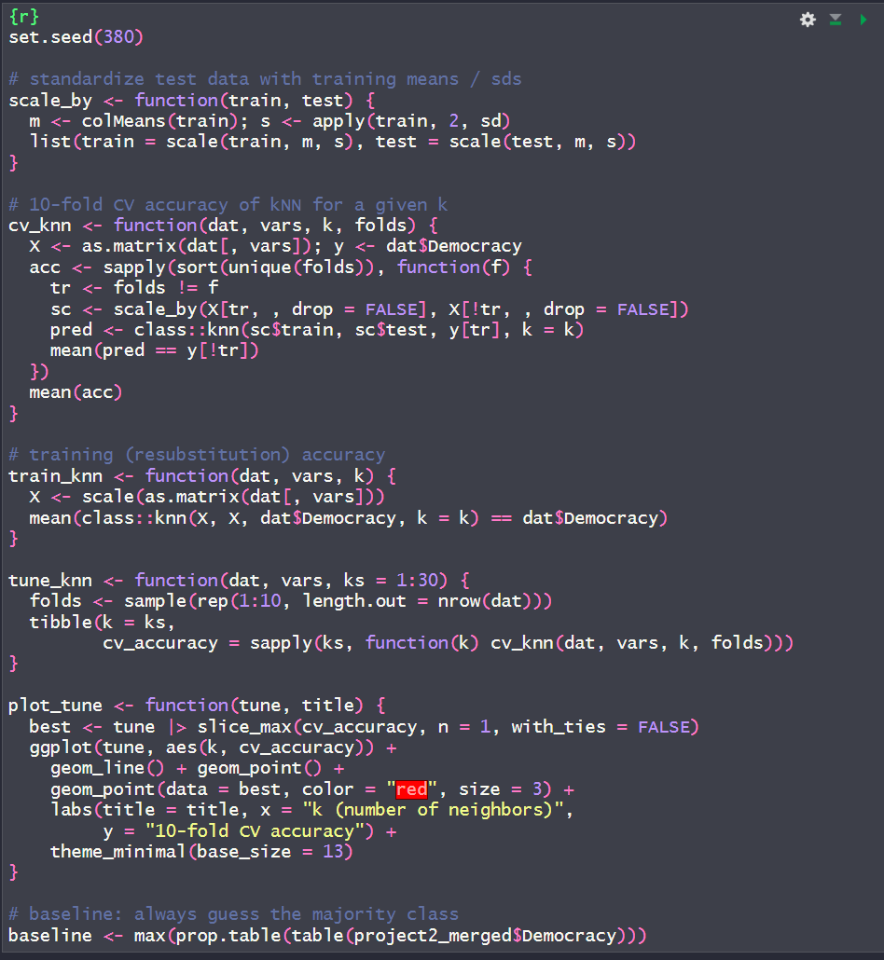 | Source: Referenced knn classification model from https://www.rdocumentation.org/packages/DMwR/versions/0.4.1/topics/kNN
KNN Single Var Model  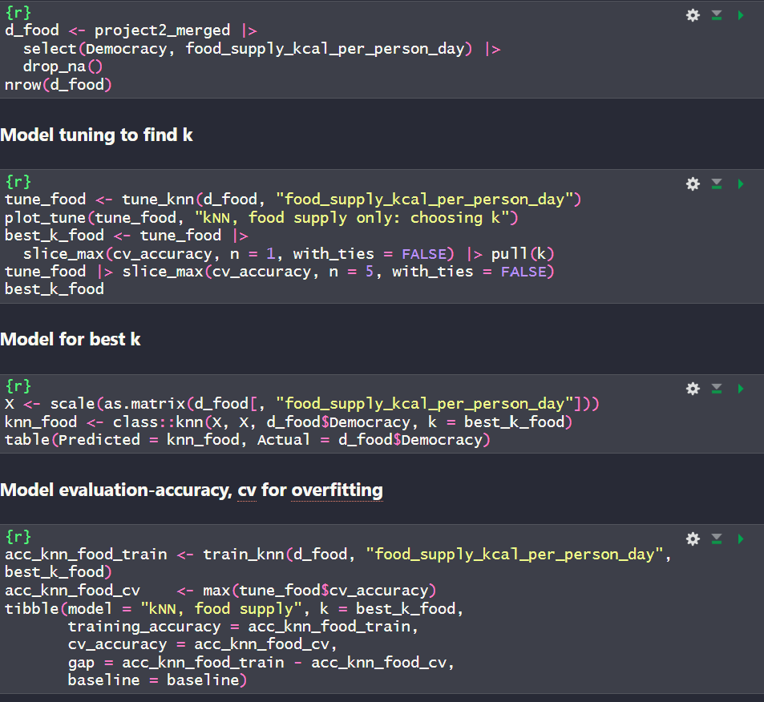 | Source: Referenced econometric implementation of a singular variable model https://www.econometrics-with-r.org/16.1-vector-autoregressions.html
KNN All Var Model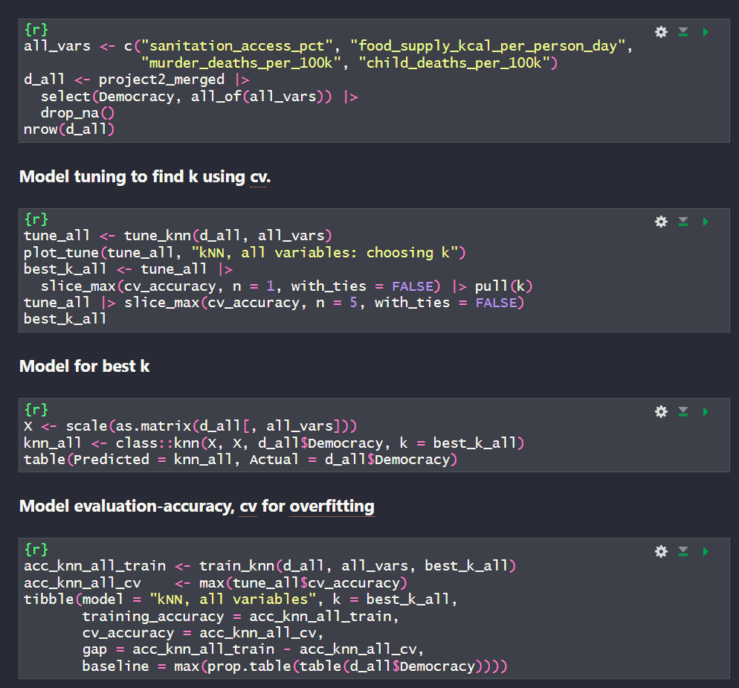 | Referenced previous implementation of single variable model
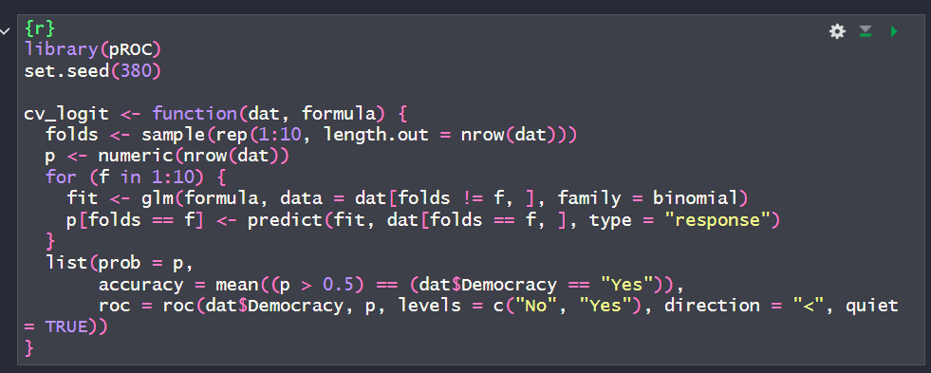 | Source: Referenced logistic regression from previous assignments
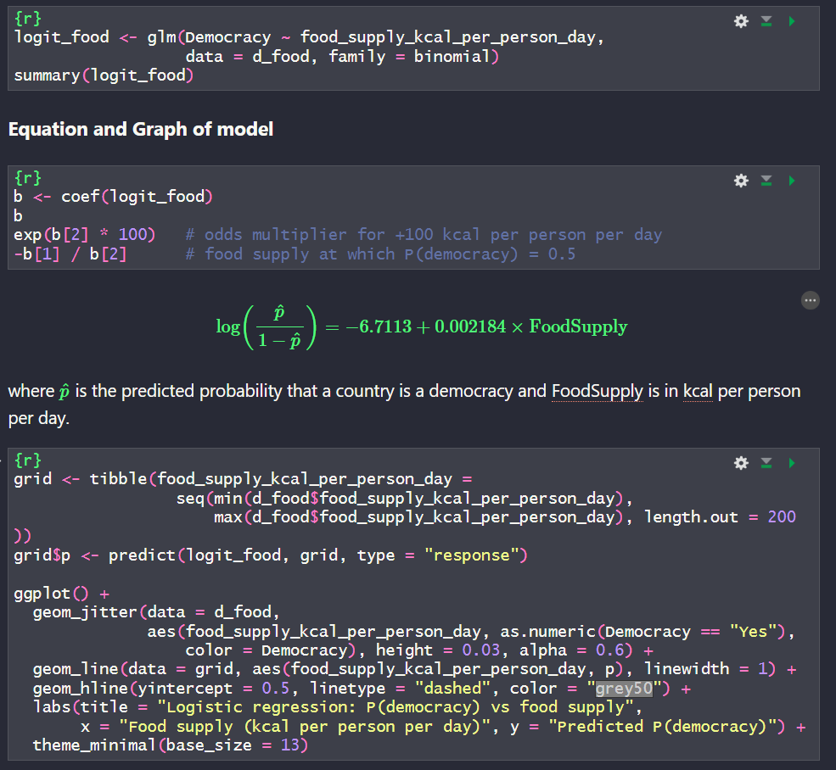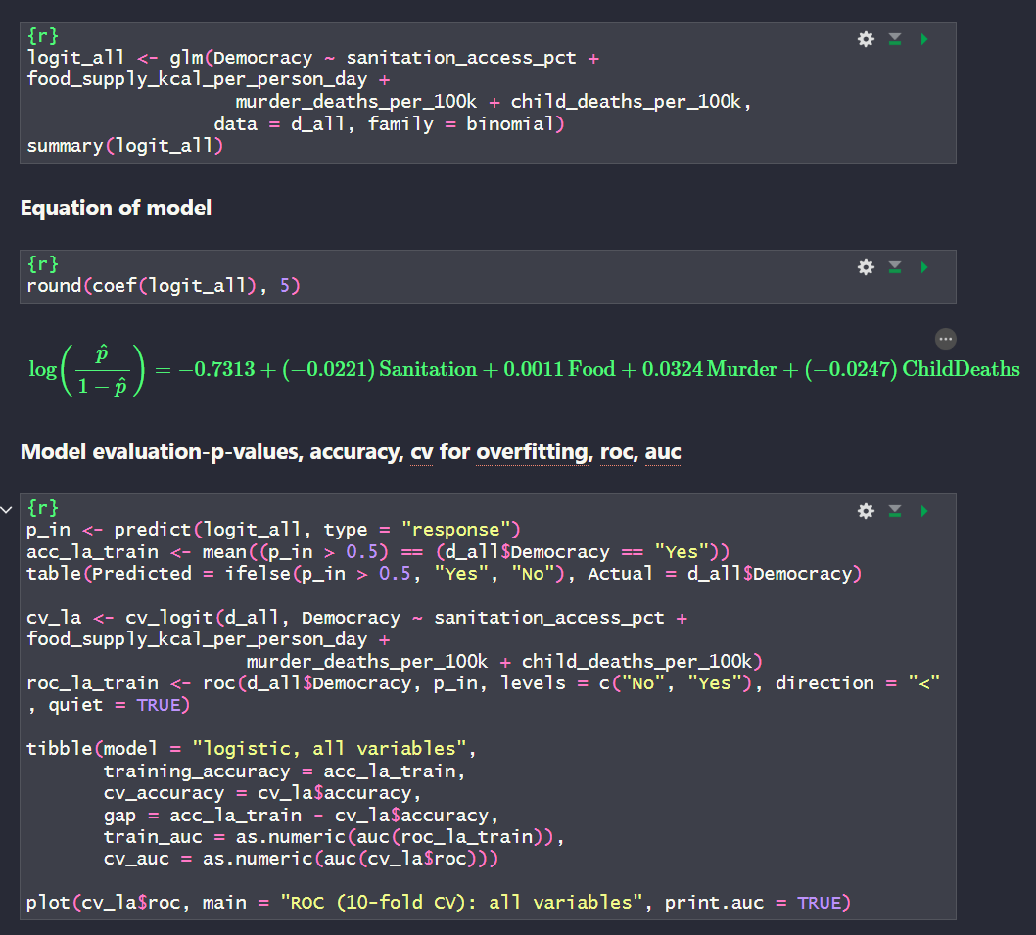 | Referenced previous implementations of single and all variable models.
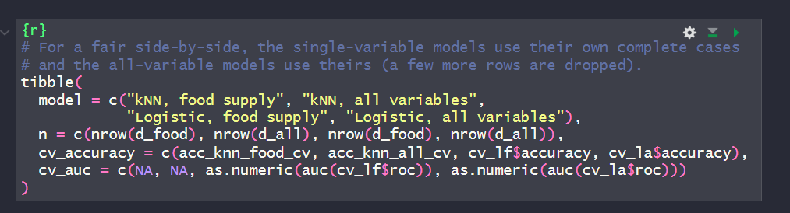 | No reference, used tibble to analyze CV range.
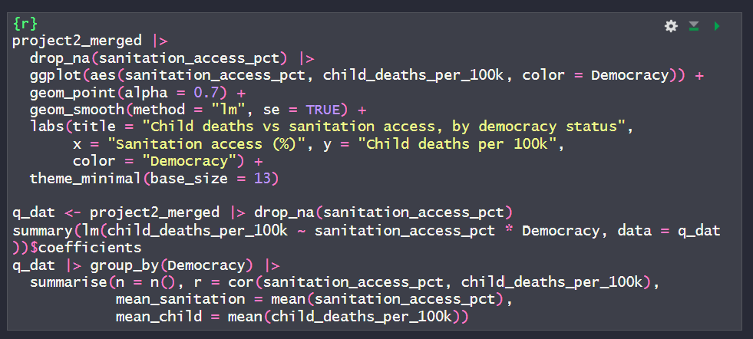 | Referenced ggplot documentation for visualization options.

